Guidance to verify and prepare the medical and relief items for exportation as per Notice 5 and Notice 12, Ministry of Commerce

Notice 5 & 12 from Ministry Commerce on Rules and Regulations of Key Medical Supplies Sourcing and Exportation from China in Response to COVID-19.

During the special period when the global epidemic continues to spread, in order to more effectively support the international community in coping with the global public health crisis, the relevant measures for further strengthening the quality control of epidemic prevention materials and regulating the export order are announced under Notice 5 and Notice 12, with respective approved (white) list and banned (black) list of manufacturers.

The process to verify the items to be exported against Notice 5 and 12 is summarized as follows:

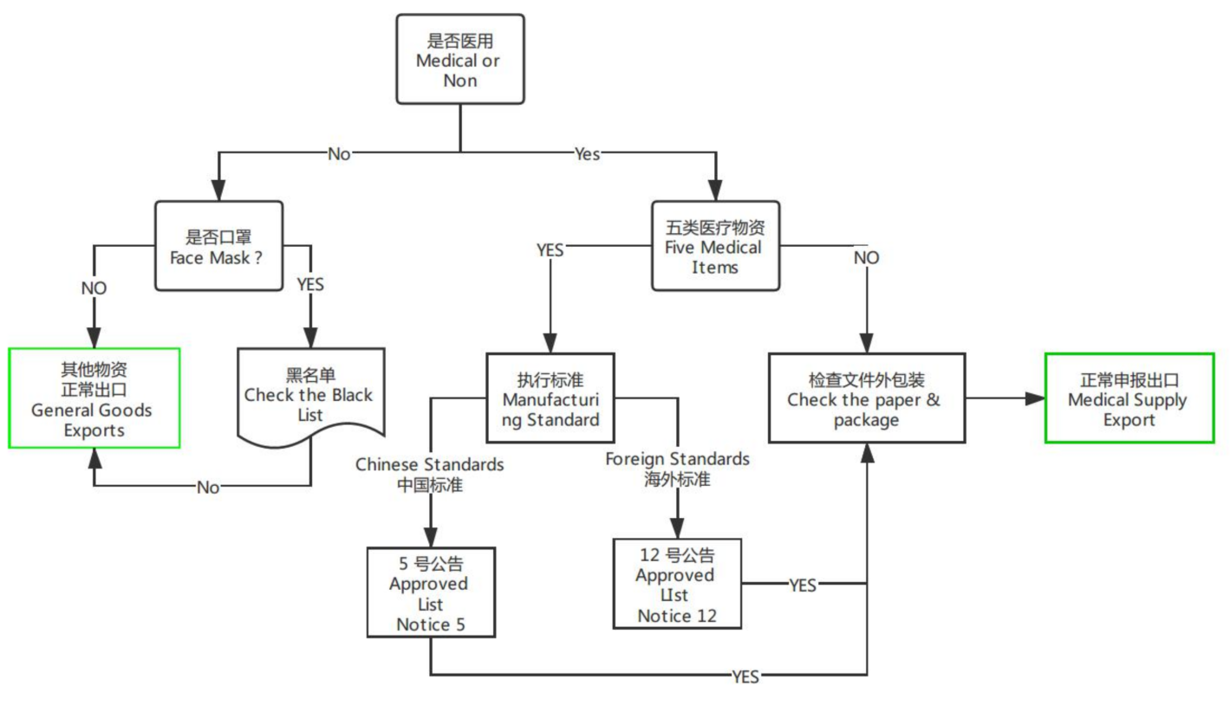

Five Item Categories: 1) Medical Masks, 2) Testing Kits, 3) Medical Protective Clothing, 4) Ventilators, and 5) Infrared Thermometers.

Five Notice 5 Approved (white) List of Five Medical Items to Meet Chinese Standards
5号公告 符合中国标准的白名单
http://www.nmpa.gov.cn/WS04/CL2582/

Notice12 Approved (white) List of Five Medical Items to Meet Foreign Standards
12号公告 符合国外标准的白名单
http://www.cccmhpie.org.cn/kywz.aspx

Notice 12 Black List of Non-medical Mask
5号公告非医用口罩黑名单
http://www.samr.gov.cn/zt/jjyq/bgt/202004/t20200427_314765.html

Checklist for the key medical supplies for exportation in response to global COVID-19

White and Black lists announced by Government of China
- 1.1 | Respective products to be verified eligible for exportation through checking against with the white and black lists issued. See the above-mentioned process flow. | Compliant (Yes/No)
生产企业许可证，执照及联系信息License/Certificates/Info on manufacturers
- 2.1 | - 《中华人民共和国医疗器械生产许可证》  - Copy of Production License of Medical Instrument of the People's Republic of China | Digital copy to upload
- 2.2 | - 《中华人民共和国医疗器械生产备案证》Copy of Record Certificate of Medical Device Production of the People's Republic of China | Digital copy to upload
2.3 | 《营业执照》  Copy of Business license | Digital copy to upload
2.4 | 联系人/方式  Contact Person/Contact emails/Tel: | Information to upload
产品信 Products Information
3.1 | 二/三类医疗物资：《中华人民共和国医疗器械注册证》，《产品检验报告》  For medical supplies under Classification Ⅱ/Ⅲ, to provide Registration Certificate for Medical Device of the People's Republic of China, Inspection Report | Digital copy to upload
3.2 | 一类医疗物资：《中华人民共和国医疗器械备案证》，《产品检验报告》，  For medical supplies under Classification Ⅰ, to provide Medical Device Production Record Certificate of the People's Republic of China, Inspection Report | Digital copy to upload
海外标准认证 Foreign Standards Certifications
4.1 | Copy of foreign standards if apply, such as:  - FDA Manufacturer certificates，  - FDA Device Listing，  - NOISH，  - CE | Digital copy to upload
对应产品采购批次采购合同 Procurement Information
5.1 | 对应物资的采销合同，发票，用以证明物资采购渠道合规合法。Copies of Procurement contract and commercial invoice to prove the legality of souring channel. | Digital copy to upload
5.2 | 交付物资的生产批次/LOT/SN码  Copy of production batch / LOT / SN code of delivered goods | Digital copy to upload
单证与实物核验建议如下（不同口岸要求不同）(Requirments/procedures vary as depature locations, e.g. Shanghai, Guangzhou

6.1 | 外箱：6 面图照片或扫描件  内件：盒装6面图，袋装2面图，照片或扫描件  照片或扫描件需要包括一下a-e要求的内容。  package carton: 6 sides.  each unit package: 6 sides if box; 2 sides if bags inside the carton  Photos/Copies of the above sides of carton and each unit package shall include the following requested information a-e. | Photos of requested package to include requested information listed below A-E
A. | 证件信息，例如生产企业，产品信息、注册证号、注册人信息，必须与物资外箱，内件包装完全一致；The certificate information including the manufacturer, product information, registration certificate number and registrant information, must be consistent with the outer box and inner package of materials; | Compliant (Yes/No)
B. | 外箱及内件包装上必须要有生产厂家、地址，联系方式，生产许可证，医疗器械注册证号、生产标准/执行标准，生产日期/批次等信息，有效期等信息；Each package carton and unit package inside the carton must have the manufacturer, address, contact information. | Compliant (Yes/No)
C. | 每个外箱及内件独立包装包装上必须要有生产许可证，医疗器械注册证号、生产标准/执行标准，生产日期/批次等信息，有效期等信息Each package carton and unit package inside the carton must have the production license, medical device registration number, production standard / executive standard, production date / batch, validity and other information; | Compliant (Yes/No)
D. | 每个内件独立包装上需要提供信息包括生产厂家，生产标准/注册证号，生产批次/有效期，加盖检验章/公章的合格证Each unit package inside the carton shall contain the manufacturer, production standard / registration certificate number, production batch / validity period, and the stamped certificate of product. | Compliant (Yes/No)
E. | 每个独立包装内件上需含有产品使用说明书Each unit package inside the carton shall have product instructions. | Compliant (Yes/No)

